***Elastic Load Balancer***

To create a classic Load Balancer:

1. Open The Amazon EC2 console

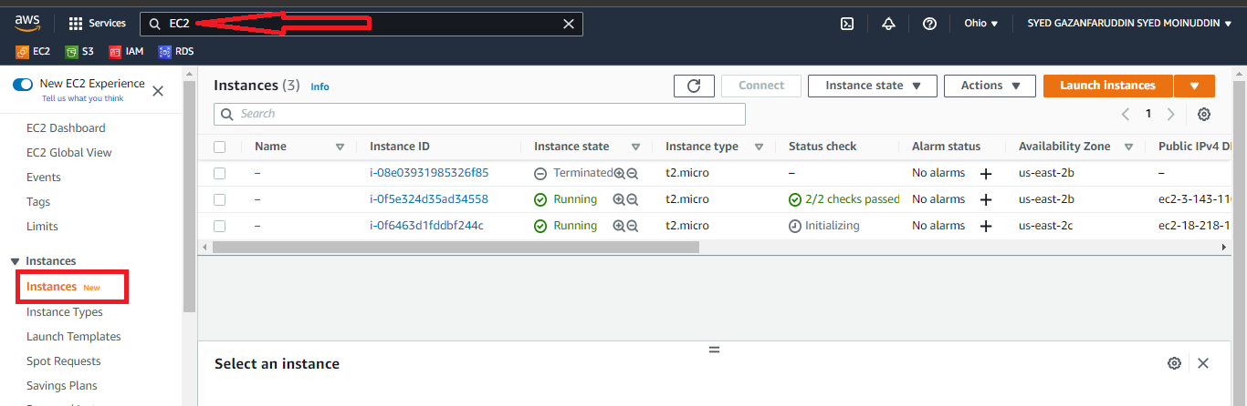

1. On the navigation bar, choose a Region for your load balancer. Be sure to select the same region that you selected for your EC2 instances.On the navigation pane, under LOAD BALANCING, choose Load Balancers.

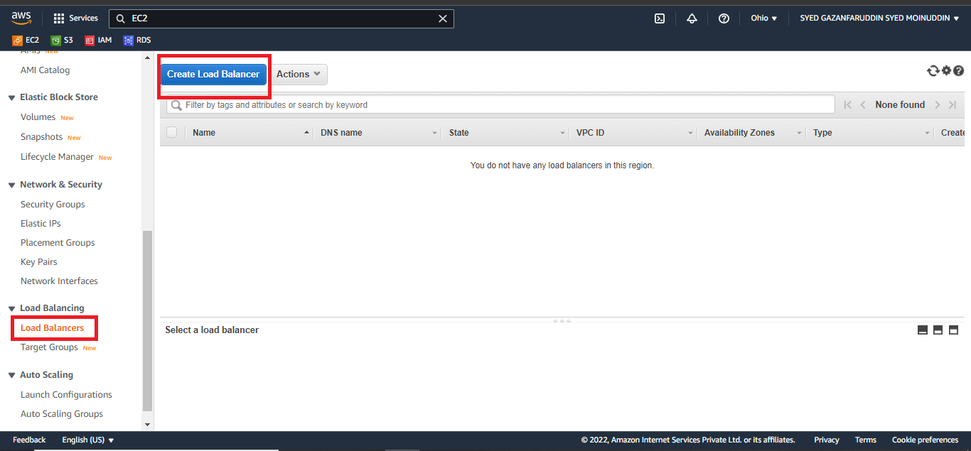

1. For Classic Load Balancer, choose to Create

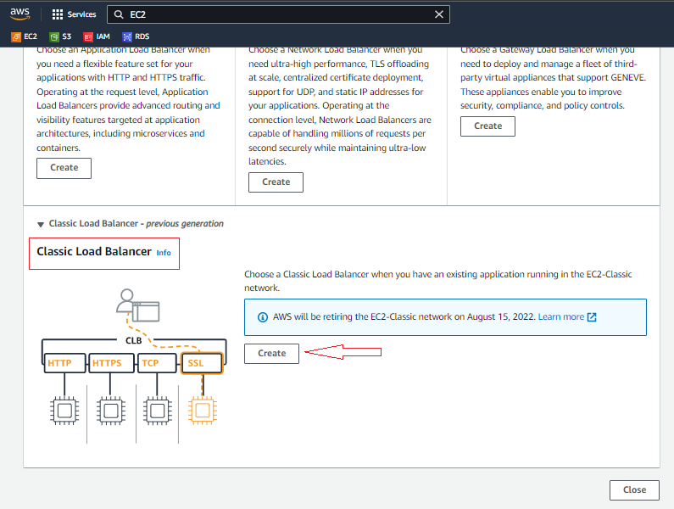

1. For the Load Balancer name, type a name for your load balancer
2. Create LB inside, select the same network that you selected for your instances: EC2-Classic or a specific VPC.
3. [Default VPC] If you selected a default VPC and would like to choose the subnets for your load balancer, select Enable advanced VPC configuration leave the default listener configuration.

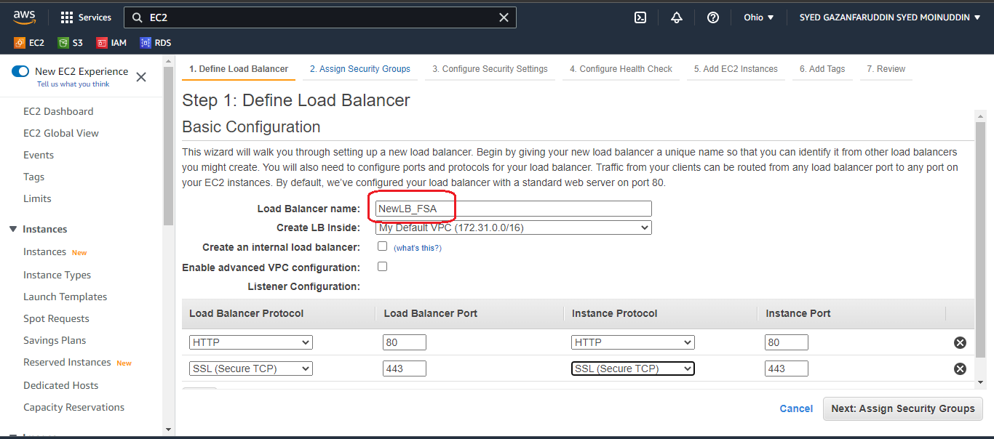

1. On the Assign Security Groups page, select create a new security group.

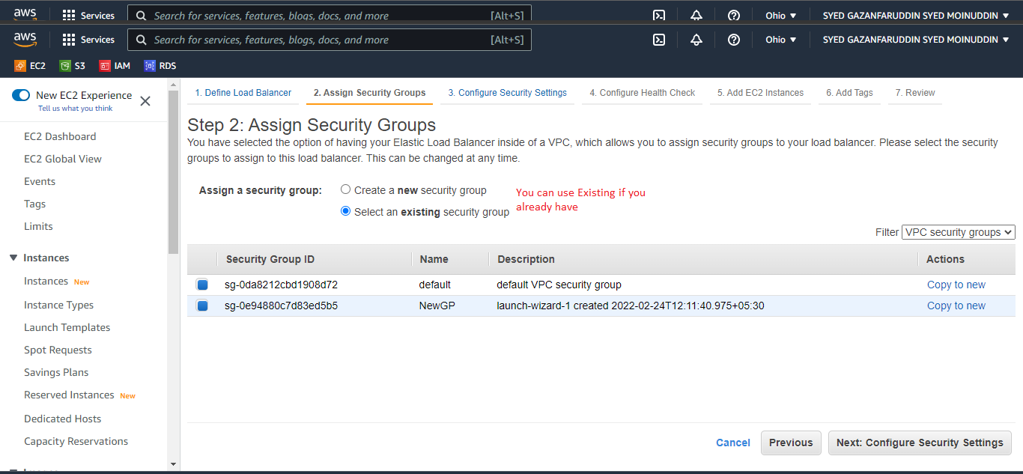

1. On the Configure Health Check page, leave Ping Protocol set to HTTP and Ping Port set to 80.
2. For Ping Path, replace the default value with a single forward-slash(/). This tells Elastic Load Balancing to send health check queries to the default home page for your web server, such as index.html.

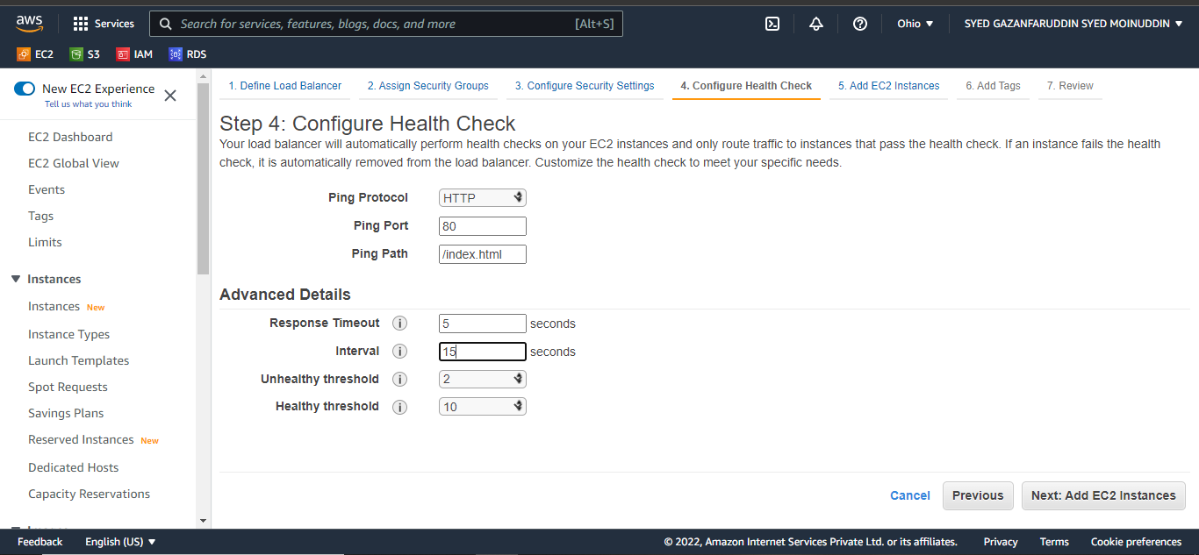

1. For Advanced Details, leave the default values.
2. Choose Next: Add EC2 Instances

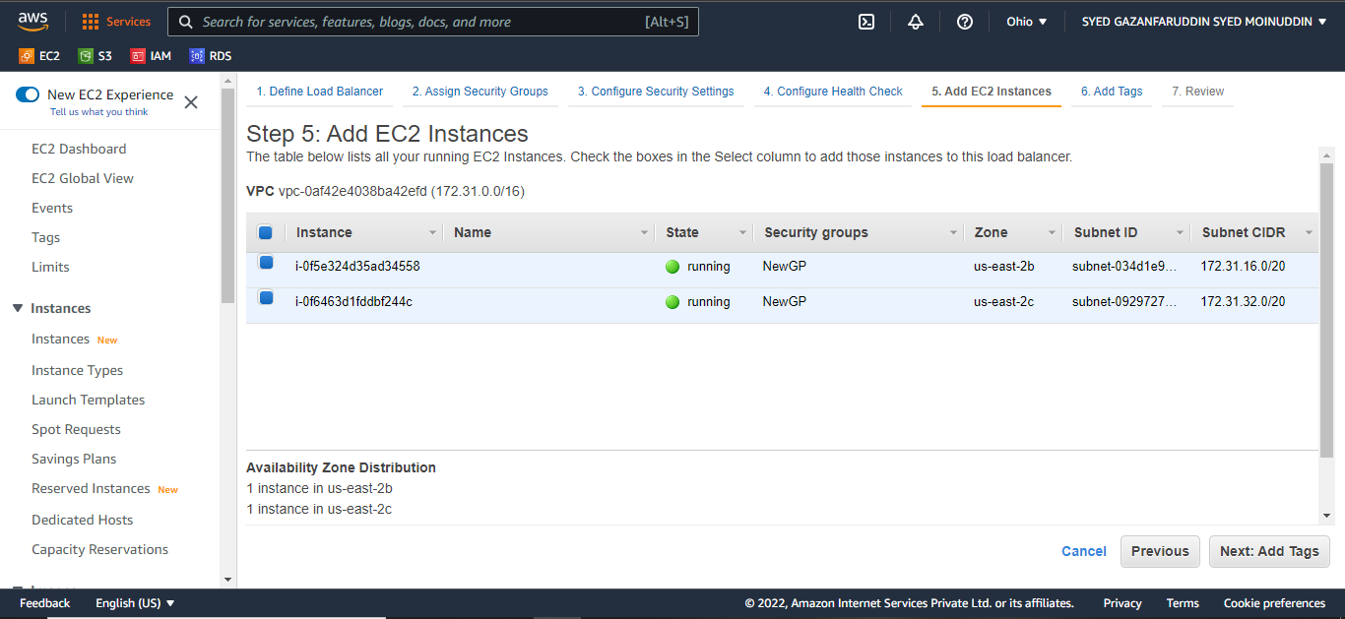

1. To register EC2 instances with your load balancer On the Add EC2 Instances page, select the instances to register with your load balancer.
2. Leave cross-zone load balancing and connection draining enabled.
3. Choose Next: Add Tags. 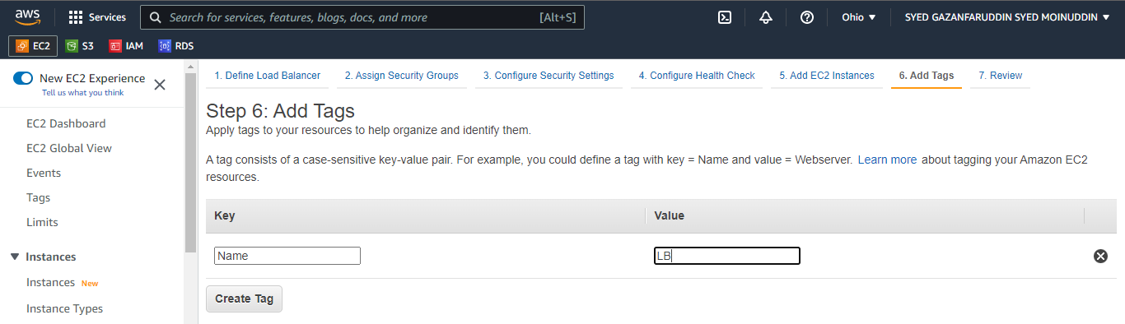
4. Alhamdulillah your Load Balancer is created successfully.

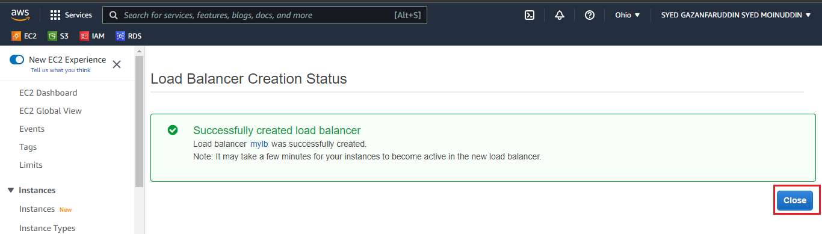

***To create and test your load balancer***

1. On the Review page, choose Create. 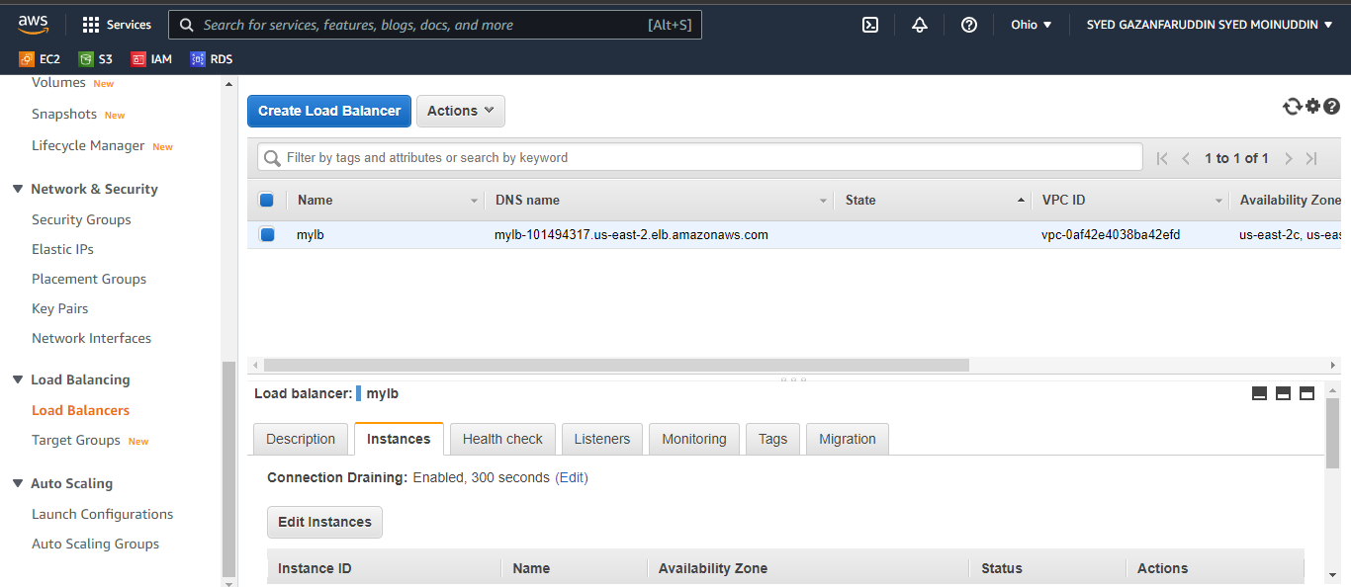
2. After you are notified that your load balancer was created, choose Close.
3. Select your new load balancer.
4. After at least one of your EC2 instances is in service, you can test your load balancer.
5. Copy the string from DNS name (for example, my-load-balancer-1234567890.us-west-2.elb.amazonaws.com) and paste it into the address field of an internet-connected web browser.